You Had Me at Math User manual

*By Kelly Bullard, Kent Jones, Susanna Quayle (additional support from AI partners Albert (Chat GDP) and Gus-Gus (Gamma.com))*



December 10, 2023

CTS - 285

Norris

Table of Contents

Table of Contents (Kelly) 1

INSTALLATION INSTRUCTIONS *(Kent)* 2

USAGE OF FEATURES (Susanna) 4

REVERSE CALCULATOR 4

TIMES TABLES 5

MATH QUIZ 6

MATH TEST 7

REGISTIRING A USER ACCOUNT 7

# INSTALLATION INSTRUCTIONS *(Kent)*

1. **Open** web browser and **navigate** to <https://github.com/susanna4004/YouHadMeAtMath.github.io>
2. **Download** code into a zip file.
   1. A screenshot of a computer

      Description automatically generated
3. **Unzip** folder and **navigate** to the folder labeled [YouHadMeAtMath (Base Folder)]
   1. A screenshot of a computer

      Description automatically generated
4. **Open** YouHadMeAtMath.html
   1. A screenshot of a computer screen

      Description automatically generated
   2. A screenshot of a computer

      Description automatically generated

# USAGE OF FEATURES (Susanna)

## REVERSE CALCULATOR

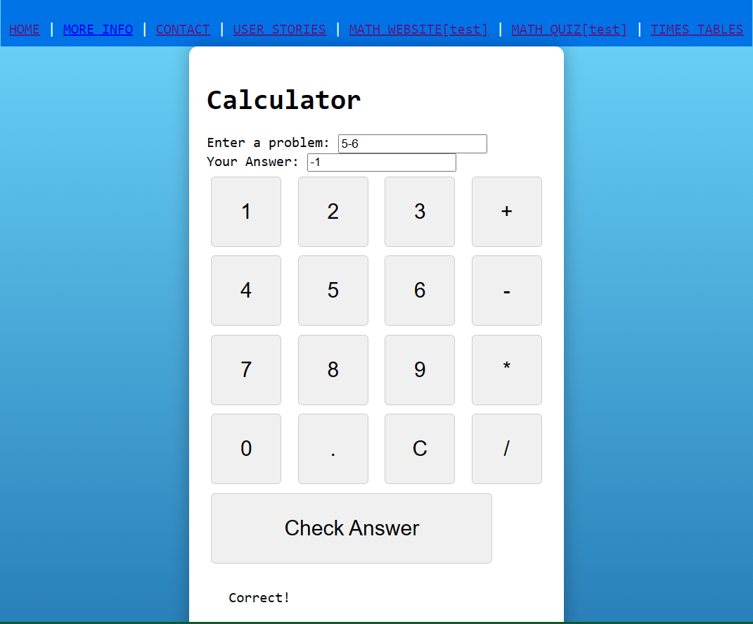

* + With the reverse calculator students will take it upon themselves to solve each problem and ReverseCalc will check their work. Students input a problem, their answer, and ReverseCalc will let them know whether their answer is correct or not. Students will challenge themselves in addition, subtraction, multiplication, and division, sharpen their mental arithmetic, and build confidence in solving math problems in real-time.

## TIMES TABLES

* + Students can master their times tables with our interactive times table practice sessions. From the basics to advanced multiplication, running through these tables will improve student’s speed and accuracy. This will help students learn to quickly recall multiplication facts and boost their mental math skills. Each times table attempt keeps track of which problems students get correct or not and will return a set of problems to practice and improve on.
  + When the user clicks the [SUBMIT] button, a progress report text file is created that records the date the activity was completed and what problems they need to study.
    - A screenshot of a computer

      Description automatically generated

## MATH QUIZ

* + The quiz section contains a defined set of problems for students to iterate through and try to solve. Math quiz can be customized by student or linked Teacher/Parent account.

## MATH TEST

* + In the math test section, users are presented with a total of five randomized sets of problems that they must iterate through and try to solve. Unlike the quiz section, the program will not tell the user if the input answer was correct or incorrect. Only when the user completes the test will their score be revealed.

## REGISTIRING A USER ACCOUNT

1. A screenshot of a computer

   Description automatically generatedType in the register key word option.
2. A screenshot of a computer

   Description automatically generatedEnter a username and password.
   1. Password requirements
      1. 1 Special characters
      2. 1 Capital Letter
      3. 1 Number
      4. A screenshot of a computer

         Description automatically generatedA minimum length of seven characters
3. A screenshot of a computer

   Description automatically generatedChoose between role of a teacher, parent, or student. Be sure to choose the role that best fits your educational direction, as each role will experience YHMAM in a different way.
4. A black rectangular object

   Description automatically generatedOnce completed, your account will be created and you’ll be brought to the user account page.

Within the User account page, users will be able to monitor their progress and track their improvement areas, test grades, achievements, complete assignments, and receive personalized recommendations to excel in math. Users with a teacher or parent role can link their student or child's account and take an active role in their math education like monitoring A blue screen with black text
their progress, viewing reports, set up quizzes, and provide guidance.